Employer Guidance for a Lawful and Safe Re-Opening
Summary of webinar (05/27/2020)
Who and When to Return to Work:
There are six phases for reopening and resuming business operations in Michigan. Executive Order 2020-96 divides the state of Michigan into eight regions.
The six phases are outlined below:
- Phase 1: Allows for the operation of: Critical Infrastructure; Government Operations.
- Phase 2: Allows for the operation of: Curbside pickup and delivery; landscaping; real estate.
- Phase 3: Allows for the operation of: Retail (by appointment only); restaurants and bars for regions 6 and 8 only.
- Phase 4: Allows for the operation of: Retail (by appointment only); restaurants and bars; dealerships.
- Phase 5: Allows for the operation of: Veterinary and non-emergency dental services.
- Phase 6: All in-person workers can return.
How to Return to Work:
Executive Order 2020-97 outlines the changes a business must make to reopen safely and in compliance. While summarized below, it is very important to read this executive order carefully. In summary:
- Do not resume business operations until you have an OSHA-compliant preparedness plan. This plan must outline all measures taken to ensure health and safety guidelines are in place. It must include all policies the business has developed to maintain compliance with OSHA and CDC guidelines and requirements.
Health screening and training protocols also need to be included.
- Businesses must have a designated COVID-19 Supervisor to oversee the business’s compliance with the preparedness plan and its requirements. The local health department must be notified within 24 hours of who has tested positive for or who has been in contact with someone who has tested positive for COVID-19.
How to Mitigate Lawsuits and Liability:
Read and keep up to date on all Executive Orders. At the time of this webinar, the following should be read carefully:
- 2020-36: Protections for those that stay at home
- 2020-69: Guidelines for government agencies
- 2020-96: Stay Home order
- 2020-97: Governs opening guidelines
Other steps to take:
- Have your required training programs ready to go.
- Check regularly for new Executive Orders and new guidelines.
- Do not stereotype. Make no decisions based on an employee’s age, risk factor, or health issues.
- Keep good records. Keep detailed records regarding all COVID-19 activities including screenings, the business’s emergency response plan, training programs and furlough/layoff records.
- Don’t wait to contact legal counsel on employment issues. If you have a question about how the law and/or Executive Order applies to your organization and or sense trouble may be brewing, contact your attorney or a member of Foster Swift’s Employment team immediately.
Who can file a claim against you?
- Employees – for violations of civil rights
- Federal and State Civil Rights Departments – can file on behalf of employee
- MIOSHA – for safety violations
- Local Prosecutors – for violations referred by local law enforcement
Resources:
- Centers for Disease Control (CDC) COVID-19 Resources
- Occupational Safety and Health Association (OSHA)
- Michigan-OSHA (MIOSHA)
- State of Michigan Executive Orders
- Michigan Coronavirus Unemployment
- Foster Swift Coronavirus Resource Page
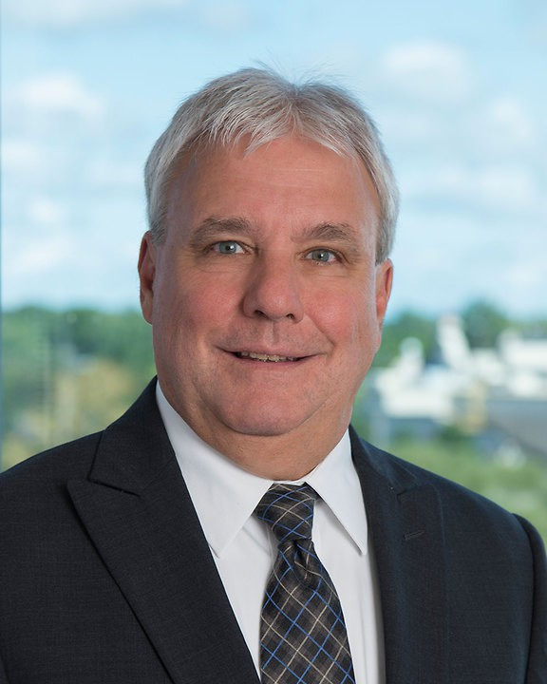
Mike Blum primarily focuses on Michigan labor and employment law and has litigated some of the state's most important cases. Mike practices in the firm's Southfield office in the areas of labor law, employment law for private employers, employment law for public employers and alternative dispute resolution.
Phone: 248.785.4722
Email: mblum@fosterswift.com

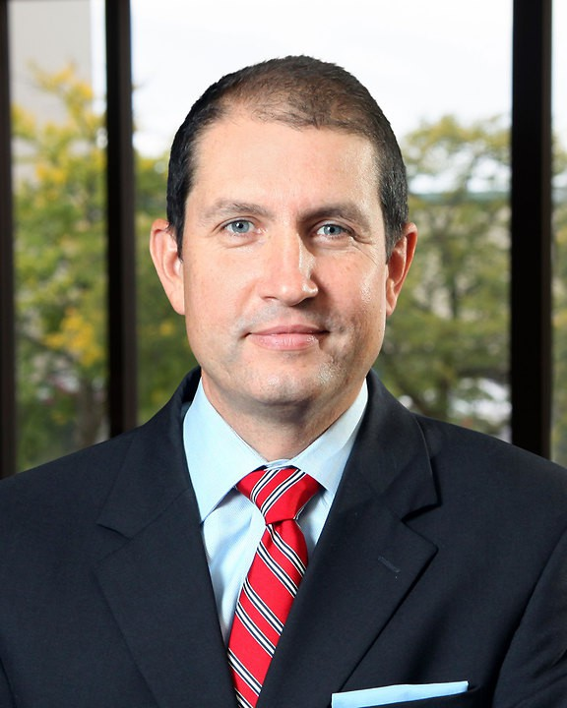
Karl Butterer is an established litigator with 20 years of highly successful legal experience. Karl currently concentrates his practice in the areas of employment, torts, civil rights, contract disputes as well as commercial litigation from the firm’s Grand Rapids office. Karl gives employers practical advice from the initial hire to the termination of the employment relationship to help them comply with the law and avoid litigation.
Phone: 616.726.2212
Email: kbutterer@fosterswift.com

Cliff Hammond is a member of Foster Swift's Employers Services practice group in the Southfield and Lansing offices where he focuses his practice on employment and labor law counsel and litigation. He has extensive experience with the National Labor Relations Act, Michigan Employment Relations Commission, Federal and State Courts, State and Federal administrative agency proceedings, collective bargaining, arbitration, mediation, union avoidance, employment litigation, and dispute resolution.
Phone: 248.538.6324; 517.371.8135
Email: chammond@fosterswift.com

